Summer Solstice Workshop,

Seasons of the Soul, with Helen Tuck.

Sunday June 21st, 2026, 2-3:30

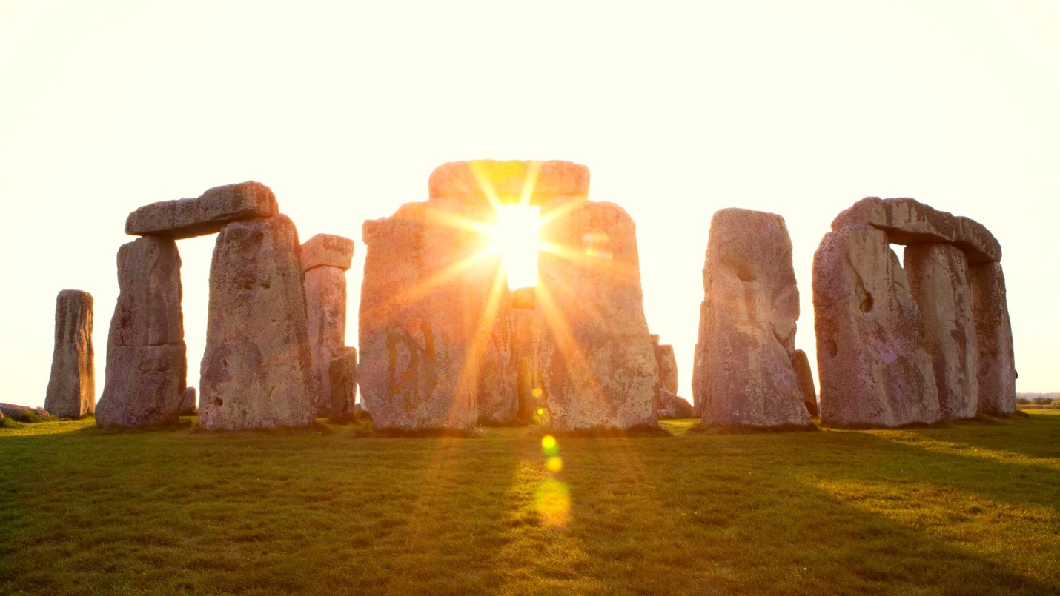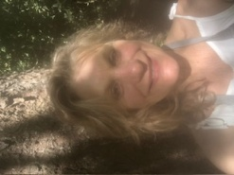

Step into the fullness of summer with intention, clarity and connection.
Seasons of the Soul is an immersive workshop designed to help you align with the natural rhythms of the Earth, beginning with the energy of the Summer Solstice.

Through sharing, discussion, and a Solstice ritual you’ll be invited to consider what you are carrying as your strengths reflected back to you through the mirror of your Soul.

Helen Tuck, teacher, counselor, artist, author and creator of women’s group work. She has created sewn masks for seasonal rituals celebrating our inner growth in connection with the seasons.

Reflections Books and Wellness, Unit 1111, 8705 Government Street, Burnaby. hello@reflections.ca. 604-939-6000

